OLNA Skill: Applies a knowledge of rate and fraction to solve multi-step questions.

- Sue ate of a pizza and Jo ate of the pizza. What fraction was left.
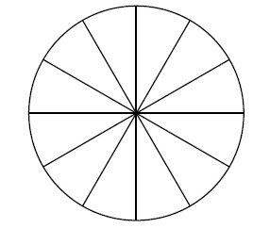
Hint: Imagine that the pizza is cut into 12 slices.

- Each night Sue has approximately 9 hours of sleep. How much sleep does she have as a fraction of a 24 hour day?

- Jo starts her holidays with $120. She spends three fifths of it during the first week. How much money does she have left to spend in the second week?

- Rowan has 4 bars of chocolate and each bar contains 16 chocolate squares. If he eats 4 squares, what fraction of his chocolate has he eaten?

Fraction problems can often be done by drawing a shape such as a circle or a rectangle and dividing it up to represent the required fraction.

For example, the diagrams below show that is equal to .

 

